**Program 4: Homepage**

**This is the implementation of Homepage for my mockups about the online laptop selling website. I used CSS and HTML for implementing this designed page. Basically, it is implementing respecting to responsive rules by using relative units and flexible positioning which can be displayed correctly on small screens devices including smartphone.**

**HTML CODES FOR HOMEPAGE**

<!DOCTYPE html>

<html lang="en">

<head>

<meta charset="UTF-8" />

<meta http-equiv="X-UA-Compatible" content="IE=edge" />

<meta name="viewport" content="width=device-width, initial-scale=1.0" />

<title>InnoGagdets</title>

<link rel="stylesheet" href="style.css" />

</head>

<body>

<header class="header">

<div class="header-elements">

<div class="logo">

<img class="color-logo" src="/images/logo.png" />

<h4 class="tagline">

buy your laptop with us today and use it forever

</h4>

</div>

<div class="search-area">

<img src="/images/search-icon.png" alt="search icon" />

<h6>search any product here</h6>

</div>

<div class="login btn">

<h1 class="btn-text">Login</h1>

</div>

<div class="one-comp">

<h4>Become a Seller.</h4>

</div>

<div class="one-comp">

<h4 class="more-text">More</h4>

<span><img src="/images/expand.png" alt="expand icon" /></span>

</div>

<div class="one-comp">

<span><img src="/images/cart.png" alt="expand icon" /></span>

<h4 class="more-text">CART</h4>

</div>

</div>

</header>

<div class="header-small-hero-categories">

<div class="one-and-category">

<img src="images/mi_computer.png" alt="computer" />

<div class="one-comp">

<h3 class="more-text">Large screen Laptops</h3>

<span><img src="/images/expand.png" alt="expand icon" /></span>

</div>

</div>

<div class="one-and-category">

<img src="images/mi_computer.png" alt="computer" />

<div class="one-comp">

<h3 class="more-text">Large screen Laptops</h3>

<span><img src="/images/expand.png" alt="expand icon" /></span>

</div>

</div>

<div class="one-and-category">

<img src="images/mi_computer.png" alt="computer" />

<div class="one-comp">

<h3 class="more-text">Large screen Laptops</h3>

<span><img src="/images/expand.png" alt="expand icon" /></span>

</div>

</div>

<div class="one-and-category">

<img src="images/mi_computer.png" alt="computer" />

<div class="one-comp">

<h3 class="more-text">Large screen Laptops</h3>

<span><img src="/images/expand.png" alt="expand icon" /></span>

</div>

</div>

<div class="one-and-category">

<img src="images/mi_computer.png" alt="computer" />

<div class="one-comp">

<h3 class="more-text">Large screen Laptops</h3>

<span><img src="/images/expand.png" alt="expand icon" /></span>

</div>

</div>

</div>

<section class="hero-section">

<div class="hero-headings">

<h2>HOT PROMOTIONS TODAY</h2>

<span> WE ARE ALSO LOOKING FOR AFFLIATES </span>

</div>

<div class="mac-pcs">

<div class="off-promo">

<img

class="mac-pc-item"

src="/images/ic_twotone-laptop-mac.png"

alt="mac pc"

/>

<h3>40% off today</h3>

</div>

<div class="off-promo">

<img

class="mac-pc-item"

src="/images/ic_twotone-laptop-mac.png"

alt="mac pc"

/>

<h3>40% off today</h3>

</div>

<div class="off-promo">

<img

class="mac-pc-item"

src="/images/ic_twotone-laptop-mac.png"

alt="mac pc"

/>

<h3>40% off today</h3>

</div>

</div>

</section>

<main class="main">

<div class="products-container">

<div class="product-item">

<img src="/images/Vector.png" class="product-image" alt="computer" />

<h2>Small size laptop</h2>

<br />

<p>

BRAND: Positivo BGH <br />

PRICE: <span class="dark-text"> 45K Rs </span>

</p>

</div>

<div class="product-item">

<img src="/images/Vector.png" class="product-image" alt="computer" />

<h2>Small size laptop</h2>

<br />

<p>

BRAND: Positivo BGH <br />

PRICE: <span class="dark-text"> 40K Rs </span>

</p>

</div>

<div class="product-item">

<img src="/images/Vector.png" class="product-image" alt="computer" />

<h2>Small size laptop</h2>

<br />

<p>

BRAND: Positivo BGH <br />

PRICE: <span class="dark-text"> 50K Rs </span>

</p>

</div>

<div class="product-item">

<img src="/images/Vector.png" class="product-image" alt="computer" />

<h2>Small size laptop</h2>

<br />

<p>

BRAND: Positivo BGH <br />

PRICE: <span class="dark-text"> 90K Rs </span>

</p>

</div>

<div class="product-item">

<img src="/images/Vector.png" class="product-image" alt="computer" />

<h2>Small size laptop</h2>

<br />

<p>

BRAND: Positivo BGH <br />

PRICE: <span class="dark-text"> 5K Rs </span>

</p>

</div>

<div class="product-item">

<img src="/images/Vector.png" class="product-image" alt="computer" />

<h2>Gaming Laptop</h2>

<br />

<p>

BRAND: Dell <br />

PRICE: <span class="dark-text"> 70K Rs </span>

</p>

</div>

<div class="product-item">

<img src="/images/Vector.png" class="product-image" alt="computer" />

<h2>Small size laptop</h2>

<br />

<p>

BRAND: Positivo BGH <br />

PRICE: <span class="dark-text"> 10K Rs </span>

</p>

</div>

<div class="product-item">

<img src="/images/Vector.png" class="product-image" alt="computer" />

<h2>Small size laptop</h2>

<br />

<p>

BRAND: Positivo BGH <br />

PRICE: <span class="dark-text"> 40K Rs </span>

</p>

</div>

<div class="product-item">

<img src="/images/Vector.png" class="product-image" alt="computer" />

<h2>Small size laptop</h2>

<br />

<p>

BRAND: Positivo BGH <br />

PRICE: <span class="dark-text"> 42K Rs </span>

</p>

</div>

<div class="product-item">

<img src="/images/Vector.png" class="product-image" alt="computer" />

<h2>Small size laptop</h2>

<br />

<p>

BRAND: Positivo BGH <br />

PRICE: <span class="dark-text"> 47K Rs </span>

</p>

</div>

<div class="product-item">

<img src="/images/Vector.png" class="product-image" alt="computer" />

<h2>Small size laptop</h2>

<br />

<p>

BRAND: Positivo BGH <br />

PRICE: <span class="dark-text"> 49K Rs </span>

</p>

</div>

<div class="product-item">

<img src="/images/Vector.png" class="product-image" alt="computer" />

<h2>Small size laptop</h2>

<br />

<p>

BRAND: Positivo BGH <br />

PRICE: <span class="dark-text"> 80K Rs </span>

</p>

</div>

</div>

</main>

<section class="section-zone">

<h2 class="heading-appliances">

buy other appliances and their compliments

</h2>

<div class="other-appliances">

<div class="item">

<img src="/images/cables.png" alt="" class="item-image" />

<h4>DELL ANG HP CHARGER</h4>

</div>

<div class="item">

<img src="/images/stand.png" alt="" class="item-image" />

<h4>Powerful STAND For Laptops</h4>

</div>

<div class="item">

<img src="/images/cable2.png" alt="" class="item-image" />

<h4>Life spanning cable</h4>

</div>

<div class="item">

<img src="/images/cable3.png" alt="" class="item-image" />

<h4>Refournished cables</h4>

</div>

</div>

</section>

<footer class="footer">

<div class="footer-category">

<h2><strong>ABOUT US</strong></h2>

<br />

<h3><a href="">Contact us</a></h3>

<h3><a href="">Contact us</a></h3>

<h3><a href="">Contact us</a></h3>

</div>

<div class="footer-category">

<h2><strong>SERVICES</strong></h2>

<br />

<h3><a href="">Resaling</a></h3>

<h3><a href="">Wharehousing</a></h3>

<h3><a href="">Returns</a></h3>

</div>

<div class="footer-category">

<h2><strong>SOCIALS</strong></h2>

<br />

<h3><a href="">Instagram</a></h3>

<h3><a href="">Twitter</a></h3>

<h3><a href="">Facebook</a></h3>

<h3><a href="">Whatsapp</a></h3>

</div>

<div class="footer-category">

<h2><strong>PROGRAMS</strong></h2>

<br />

<h3><a href="">Stripes </a></h3>

<h3><a href="">Affliations</a></h3>

<h3><a href="">Advertizement</a></h3>

</div>

</footer>

</body>

</html>

**CSS STYLES FOR HOMEPAGE**

@import url('https://fonts.googleapis.com/css2?family=Nova+Cut&display=swap');

*{

box-sizing: border-box;

margin: 0;

padding: 0;

}

body{

font-family: Verdana, Geneva, Tahoma, sans-serif;

color: white;

}

a{

color: white;

text-decoration: none;

}

.header{

width: 100%;

background-color: transparent;

}

.header-elements

{

border: 2px gray solid;

position: relative;

display: flex;

max-height: 100px;

justify-content: space-around;

width: 100%;

background-color: white;

opacity:0.5;

padding: 1rem;

}

.logo{

width: 20%;

display: block;

}

.tagline

{

color: black;

font-size:0.5rem;

}

.search-area{

width: 45%;

height: 40px;

border-radius: 10px;

border: 3px black solid;

display: flex;

color: black;

gap: 0.4rem;

align-items: center;

justify-content: first baseline;

margin-left: 1.5 rem;

padding: 1rem;

margin-right: 1rem;

}

.btn{

width: 120px;

padding: 0.4rem 1rem;

align-items: center;

height: 40px;

z-index: 1;

border-radius: 5px;

background-color:#ffb915ec;

}

.btn-text{

font-size: 1.2rem;

align-self: center;

color: black;

padding: 0rem 1rem ;

}

.one-comp{

position: relative;

width: auto;

display: flex;

color: black;

margin-left:0.7rem ;

}

.header-small-hero-categories{

width: 100%;

height: max-content;

color: black;

display: flex;

justify-content: space-between;

padding: 1rem;

border: #8A9A5B 1px solid;

position: relative;

font-family: 'Nova Cut', monospace;

}

.hero-section{

width: 100%;

max-height: 400px;

display: block;

padding: 2rem;

background: rgba(138, 154, 91, 0.52);

}

.mac-pcs{

display: flex;

justify-content: space-between;

}

.mac-pc-item{

background-color:transparent;

width:auto;

}

.off-promo{

color: black;

}

.hero-headings{

display: flex;

justify-content: space-around;

color: black;

}

.main{

position: relative;

background-color: white;

width: 100%;

height: auto;

padding: 1rem;

}

.products-container{

width: 100%;

position: relative;

display: flex;

gap: 2rem;

flex-flow: row wrap;

justify-content: space-between;

}

.product-item{

background-color:#8A9A5B;

width: max-content;

border-radius: 5px;

display: block;

align-self: center;

color: white;

border: #8A9A9B 2px solid;

padding: 0.5rem 1rem;

}

.product-image{

margin-left:2rem;

padding: 1 rem;

background-color: transparent;

}

.dark-text{

font-family: 'Quarto ';

font-weight: 700;

color: black;

background-color: rgba(255, 166, 0, 0.404);

border-radius: 5px;

font-size: 1.5rem;

padding: 0.2rem;

}

.section-zone{

background: rgba(138, 154, 91, 0.92);

border: 2px solid #FFB715;

color: black;

} .other-appliances{ width: 100%;

gap: 2rem; max-height: 400px;

justify-content: space-between;

padding: 2rem; border-radius: 10px;

display: flex; color: white;

} .heading-appliances{

text-align: center;

color: black;

}

.footer{

width: 100%;

height: auto;

background-color: black;

position: relative;

display: flex;

padding: 2rem;

justify-content: space-between;

gap: 1rem;

}

.footer-category

{

display: block;

line-height: normal;

color: white;

}

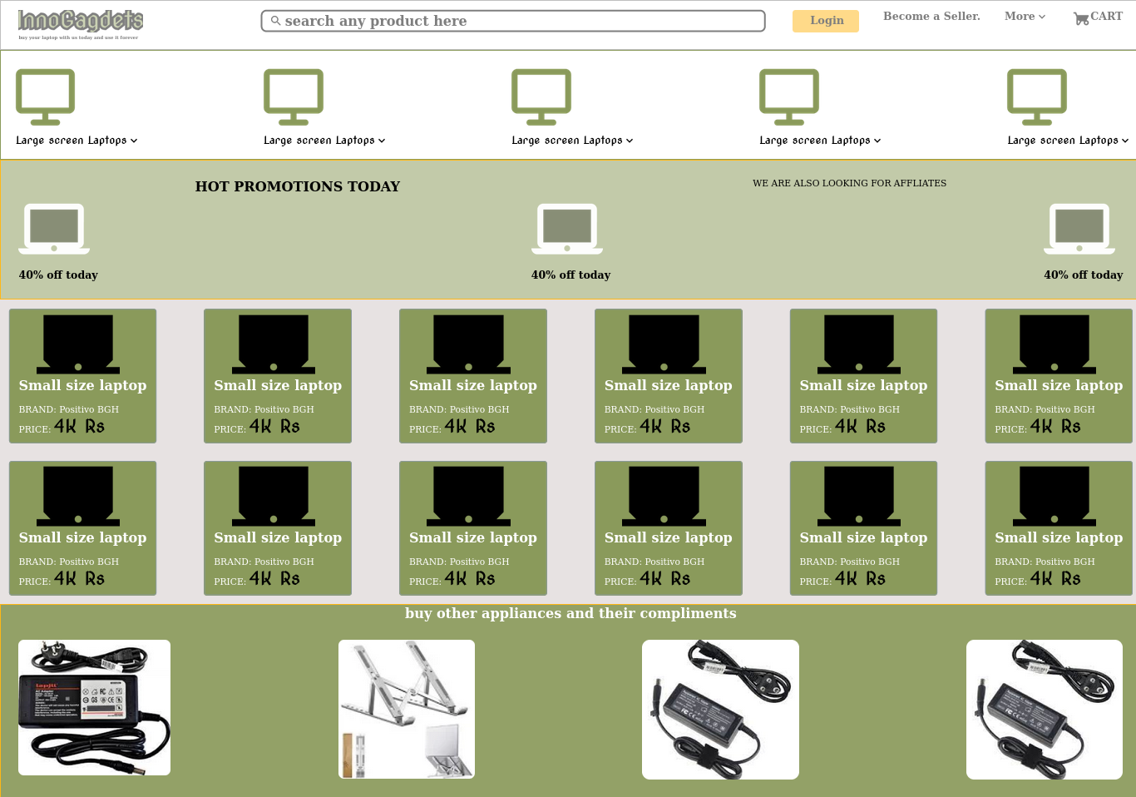**OUTPUT: OUTPUT –HOMEPAGE SCREENSHOT**